Luxury Features Homeowners Wish They Had Included Sooner
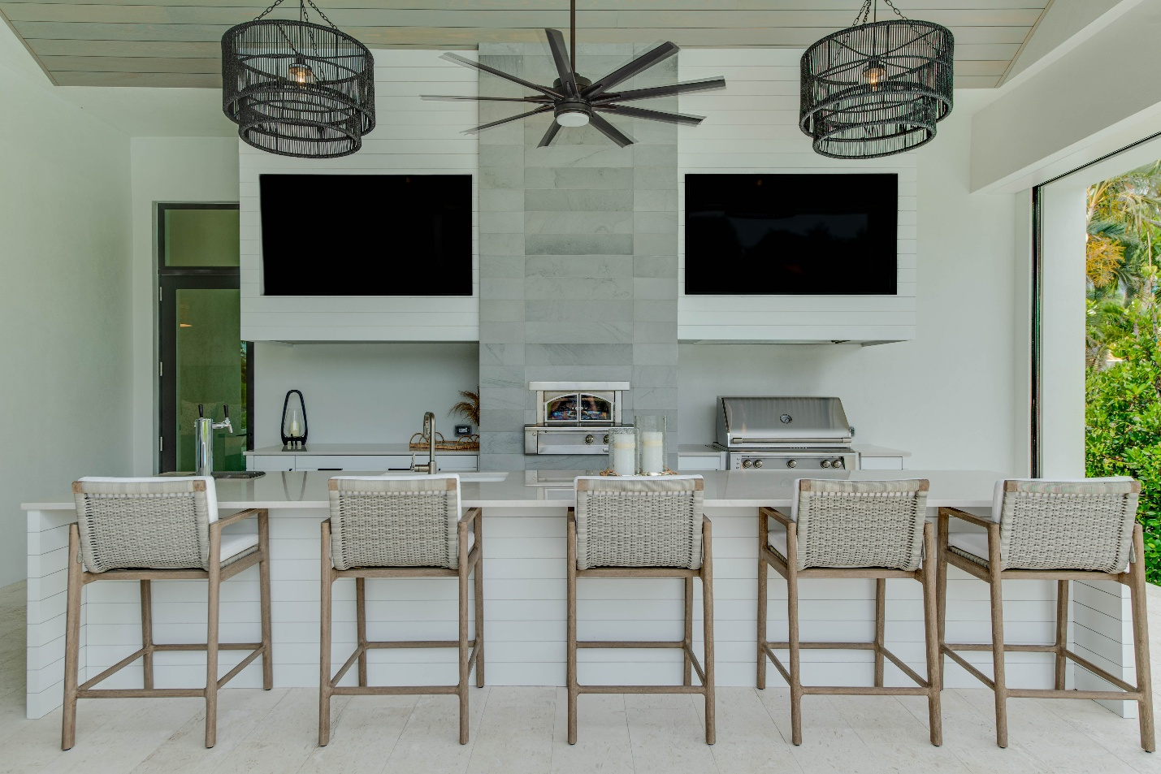
At Gulfstream Homes, we know that exceptional craftsmanship and quality extend far beyond what meets the eye. They’re found in intentional planning, precise execution, and personalized details that make every home truly one of a kind.
Whether we're building a custom estate home or breathing new life into an existing residence through complete renovation, attention to detail is at the heart of everything we do.
New Homes: Building Beyond Expectations
Some of the most valued luxury features are often the ones homeowners didn’t realize they had until after they’ve moved in. Building a custom home gives you the opportunity to incorporate intentional design elements that enhance everyday living from day one.

Hidden Details That Matter:
- Custom millwork and architectural trim
- Built-in storage solutions that maximize organization
- Seamless indoor-outdoor living spaces
- Carefully planned sightlines throughout the home
- Elevated ceiling treatments and architectural details
These are the features that may go unnoticed at first glance but become the details homeowners appreciate every single day.
Remodeling & Renovations: Reimagining the Home You Love
Sometimes the perfect home is the one you already own.
A successful renovation goes beyond updating finishes or replacing fixtures. It’s about improving how your home functions, flows, and supports the way you live today.

Our Remodeling & Renovations Division specializes in transforming existing homes into beautiful, functional spaces tailored to each homeowners’ lifestyle.
Whether it's:
- Whole-home renovations
- Kitchen remodels
- Home additions
- Outdoor living transformations
- Luxury bathroom renovations
- Reconfigured floor plans
Our experienced team brings the same creativity and commitment to quality that defines every Gulfstream custom home.
The Gulfstream Difference
For 28 years, Gulfstream Homes has been helping families throughout Southwest Florida to build, remodel, and renovate homes that stand the test of time.
Our commitment to open communication and personalized service is what sets us apart, and why so many homeowners choose Gulfstream Homes time and time again.
Ready to start your next project? Contact our team today to learn how we can bring your vision to life. Call us today at (239)-254-1664.

